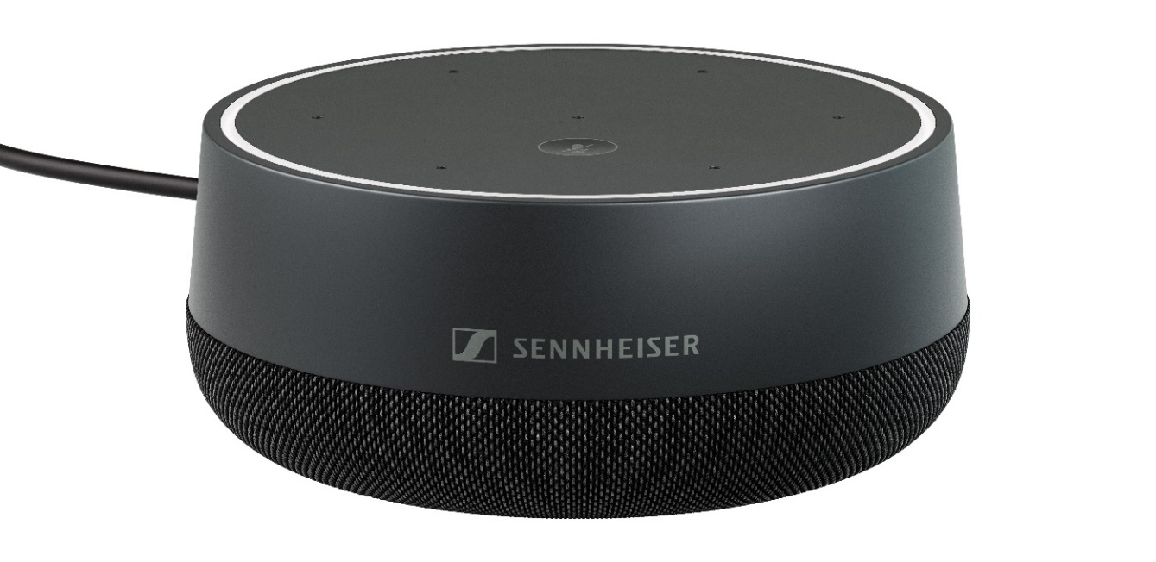
Sennheiser Introduces TeamConnect Intelligent Speaker for
Microsoft Teams Rooms
New Unified Communications Solution Will Be Showcased During Online Webinars Today

Wedemark, 16 February 2022 – Sennheiser, the first choice for advanced audio technology that makes collaboration and learning easier, is pleased to announce an intelligent speaker Certified for Microsoft Teams, the TeamConnect Intelligent Speaker. Originally planned for launch at Integrated Systems Europe (ISE) 2022, the new unified communications solution for mid-sized Microsoft Teams Rooms will now be launched during free, live online seminars today. To join, visit https://mautic-dev.sennheiser.com/product-launch-registration-en.

With the TeamConnect Intelligent Speaker, Sennheiser is delivering a solution to support smart, focused and inclusive meetings for up to 10 people, whether participants join remotely or are in the room. It features an omnidirectional speaker that covers a 3.5m radius and seven integrated beamforming microphones to achieve impeccable sound quality. Through this Intelligent speaker, Microsoft Teams provides and automatic meeting transcript in real-time, identifying the individual people speaking by name, in case they have enrolled their voices. This provides an inclusive meeting experience for remote and hard-of-hearing participants.

“Sennheiser is known for our industry-leading TeamConnect Ceiling 2 microphone with TruVoicelift,” said Anne Guhn, Product Manager at Sennheiser. “This addition to our TeamConnect family offers an opportunity for us to expand into a different sized meeting room, at a price point that some might not expect from Sennheiser.”

Intelligent solutions, such as the integrated Cortana voice recognition software and automatic meeting notes, make an inclusive meeting experience possible for remote and hard-of-hearing participants. With multiple mounting options, long cables and a variety of country-specific power plug adapters, the TeamConnect Intelligent Speaker offers an easy and flexible installation experience.

“Video conferencing tools like Microsoft Teams have become the communication backbone for many businesses and education institutions,” Albert Kooiman, Senior Director of Microsoft Teams Devices Partner Engineering and Certification, said. “The Sennheiser TeamConnect Intelligent Speaker does not only provide excellent meeting room audio, but also unlocks the best speech technology. Only Intelligent Speakers offer the best speech transcripts.”

Microsoft Teams Rooms combines the virtual workspace of Microsoft Teams with real-world meeting rooms that feature AV equipment from Microsoft-certified hardware partners.

Replays of the launch online seminars are available for view at your convenience by visiting https://sennheiser.com/business-events. There, you will also find other virtual seminars highlighting Sennheiser’s suite of business communication solutions.

(Ends)

The images accompanying this press release and additional photos can be downloaded here.

About Sennheiser
Shaping the future of audio and creating unique sound experiences for customers – this aim unites Sennheiser employees and partners worldwide. The independent family company, which is managed in the third generation by Dr Andreas Sennheiser and Daniel Sennheiser, is today one of the world’s leading manufacturers of headphones, microphones, and wireless transmission systems. In 2020, the Sennheiser Group generated turnover totaling €573.5 million. www.sennheiser.com

Global Press Contact

Jeff Horan
+1 860-598-7539
jeffrey.horan@sennheiser.com

